**Class quiz to be recorded/10**

Question1.

a. What is *data mining*?

b. Describe the steps involved in data mining when viewed as a process of knowledge discovery.

c. How is a *data warehouse* different from a database? How are they similar?

d. Give and briefly explain at least five characteristics of *Data quality*

**question2.** Define the following terms:

1. Confidence
2. Support
3. Frequent pattern

**Question3**. Given the table below, given minimum support of 50% and minimum confidence of 50%

1. identify the frequent items from table

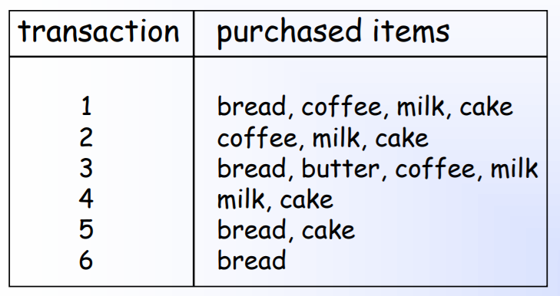

1. Calculate the support and confidence of the following rules

{milk, coffee} ⇒ {cake} 6%

{Milk} => {coffee, cake}

End